***Neural Circuit Policies – NCP***

*What are NCPs?*

* Neural Circuit Policies (NCPs) are designed sparse recurrent neural networks loosely inspired by the nervous system of the organism [C. elegans](http://www.wormbook.org/chapters/www_celegansintro/celegansintro.html).
* NCPs are a type of sparse neural network (NN) where its neurons have enhanced capabilities:
  + The neurons on a typical NN are called ‘perceptrons’ which compute linear operations + a non-linear operation per layer.
  + On the other hand, NCPs contain a type of neurons called *‘liquid time-constant’* (LTC) or *‘closed-form continuous-time’* (CfC). These neurons are capable of solving *‘ordinary differential equations’* (ODE) instead.
* Another distinct attribute of NCPs is the special wiring between neurons. The NCP architecture consists of four layers: sensory-inter-command-motor neurons:
  + *Sensory:* These neurons specialize in receiving the inputs. The number of sensory neurons required is the corresponding number of features the input has. The connection between the sensory layer and the inter-neuron layer is done fully.
  + *Inter:* These neurons specialize in distributing the information perceived in the sensory neurons to the command neurons in a statistical form. The connections between these two layers are described later in the *‘Wiring’* section.
  + *Command:* These neurons specialize in deciding what will the output be acting like a council, where each neuron receives a part of the information via the statistical synapses from the inter neuron layer and the processed information can be also passed to other command neurons. This layer can be interpreted as an attention layer with missing connections from the previous and the actual layer. The connection between the command layer and the motor layer is done fully.
  + *Motor:* Theseneurons specialize in returning the output. The number of motor neurons required is the corresponding number of targets desired.
  + *Wiring:* The connection between two consecutive layers is decided in two steps:
    - *1st Inter-Layer Connections:* For every neuron in the source layer, select *‘n’* neurons of the target layer from a Binomial distribution with probability p1 and choose the polarity of the synapse from a Bernoulli distribution with probability p2. The polarity Determines if the synapse is excitatory or inhibitory.
    - *2nd Intra-Layer Connections:* For every neuron in the target layer with no synapses, select *‘m’* neurons of the target layer from a Binomial distribution with probability p3 and choose the polarity of the synapse from a Bernoulli distribution with probability p2. The polarity Determines if the synapse is excitatory or inhibitory.

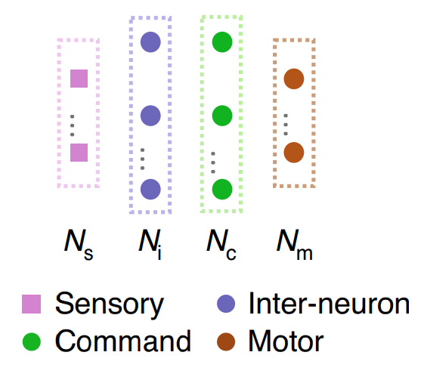

Architecture of and NCP

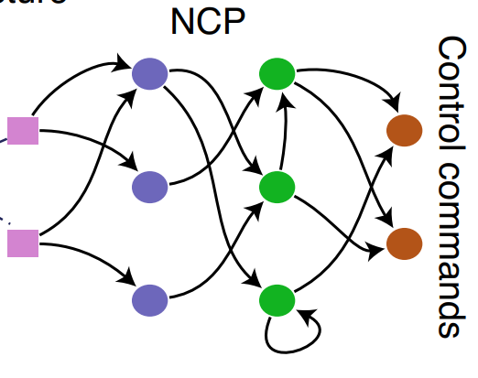

Sample of synapses of and NCP

*What are LTCs?*

* LTCs are a special type of neurons with two special capabilities:
  + Their mathematical process consists of solving differential equations numerically via iterative methods using the inputs as the initial state instead of applying as linear transformation to the inputs. This special functioning makes training these neurons extremely slow but also extremely reduced the number of neurons required for a model to produce good results.
  + Their parameters are not constant like perceptrons, they adjust the parameters based on the inputs to adjust the velocity response of the neuron. This allows to reduce noise when a neuron is not required making it ‘lag’ (or delaying the response). On the other hand, when a neuron is required, the parameters are adjusted to enhance the response.

*What are CfCs?*

* CfCs are a version of LTCs that instead of solving and ODE directly, they first approximate the solution with a closed form. This enhances the speed of the solution making the training much faster at the cost of some accuracy